# **Folder Structure for AUTMHQ Job Board python scripts**

1. Main Folder

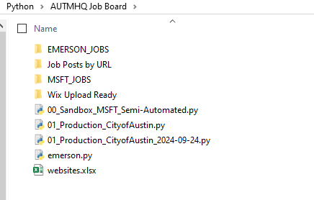

1. Folder with Output for City of Austin – Job Posts By URL

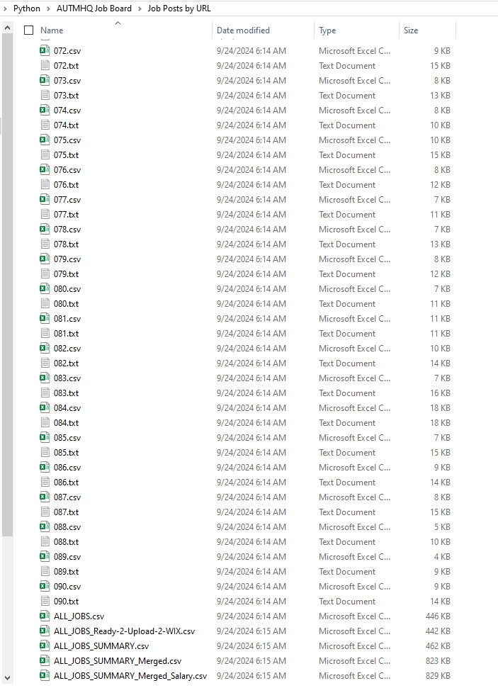

1. Folder with output for Microsoft: MSFT_JOBS

